# Presentation Powerpoint:

<https://primarystrand-my.sharepoint.com/:p:/g/personal/avinash_gyawali_abphina_com/EUHmYjoDYrZEgBtHYpsUFz4BHIGc5C79UbchpjnxjBVN6Q?rtime=XHb5neyO20g>

# Final Presentation

Notes I (David) wrote:

* For final presentation:
  + History and importance of simulation learning
  + History and importance of game theories
  + Teach them about game design
  + Bring them together maybe by referring to something they might be more familiar with (ex: wheel of fortune → don’t use this tho)
  + Discuss problem in industry and how our game solves this problem
  + Etc etc
  + Last 25% goes directly into what we worked on in summer
  + Take them on a journey
  + Don’t focus too much on what we did
  + Smooth transitions
  + ***We’re trying to *sell* this product***
    - Must be able to convince audience that this is worth it
  + Find out about audience and see how to catch their attention
  + 15-20 minutes per team
  + At least talk for 2 minutes about what you learned from this internship and how it benefited you in academia and professional aspect and such
  + Audience:
    - Physician
    - Pharmacist
    - Computer Scientist
    - Mostly in life science industry
  + Make document outline of presentation:
    - Topics we’ll discuss, how long, who’s saying it

1. History of simulation learning
2. History of game theory
3. Problems in skill acquisition - The corporate world
4. Simulation learning in the business world
5. Talk about how much money can be saved with simulation learning
6. Product development
7. Current simulation learning scenario in the business world
8. What we learned in the internship ?
9. Future RoadMap

**Goals**

1. Make it very interesting

**Outline (Incomplete)**

**\*\*Don’t have too many slides - for example, condense part 2 into one slide\*\***

1. History / Importance section of Simulation learning / game theories
   1. For importance:
      1. Why it exists
      2. Benefits
      3. Common occurrences
2. Teach about General Game Design → Not exactly Vitalblinks
   1. What is it
   2. How it works
   3. Things we have to consider
   4. Importance
3. The problem that Vitalblinks solves
   1. Also overall benefits of Vitalblinks
   2. Practicality / Convenience / Reusability of it → get points from Vitalblinks videos
4. Discuss our work
   1. *LAYMAN’S TERMS! Explain in way they’ll understand and we must heavily simplify things*
   2. How we used game theories
   3. How we used game design
   4. Our SRS document / Miro / Figma
      1. For each:
         1. What it is
         2. How it helps
         3. What we had to do
5. Brief discussions about our experiences 9 minutes, 3 minutes each person
   1. What we enjoyed
   2. What we learned
   3. How we benefited

Total Time: 30 minutes

# Final Presentation Slide Contents / Flow

**Simulation Learning - David**

* History
  + When it was created
    - Seems it was discovered as early as 24,000 - 22,000 BC [link](https://www.ncbi.nlm.nih.gov/pmc/articles/PMC9276079/)
    - Models exist of clay liver (1,900 - 1,600 BC) [link](https://www.ncbi.nlm.nih.gov/pmc/articles/PMC9276079/) as well as other clay models of human anatomy around 200 BC [link](https://www.apsf.org/article/the-evolution-and-role-of-simulation-in-medical-education/)
  + Evolution?
    - First examples of “modern” simulation around 1960’s by Dr. Peter Safar who was the centerpiece of creating the CPR mannequin [link](https://en.wikipedia.org/wiki/Resusci_Anne)
    - David Gaba and colleagues created an anesthesia computer simulation, as was one of the first examples of computer simulation learning [link](https://www.apsf.org/article/the-evolution-and-role-of-simulation-in-medical-education/)
* Importance
  + Why they’re used / Benefits
    - Can provide first-hand experience which leads to learning extra necessary skills
    - More deeply engaging than other activities
    - Can practice unexpected situations
    - Don’t need to use real-situations and make real risks
  + Common uses
    - Medicine
    - Driving / Flying
    - Military
    - [Link](https://www.bestcolleges.com/blog/simulation-learning/)
* Transition: (Talk about our product needing game theories cause of business aspect / multiplayer)

**Game Theories - David**

* History
  + When it was created
    - Basic ideas written by Gerolamo Cardano around 1564
  + Evolution?
    - More developments by multiple people until John von Neumann published paper on it in 1928, making game theory a unique field on its own
* Importance
  + Benefits / Common uses
    - Study and understand human / animal behaviors
    - Study and understand economic behaviors
    - Develop ethical / normative behavior theories
* How it’s used in VitalBlinks
  + Each level uses a specific game theory in order to test a player’s ability to approach each one and act accordingly
* Transition: In addition to game theories, another aspect that we have to look at is their design

**Game Design of Simulation Learning -** Avinash

* ***\*\*Game Design in general, not about VitalBlinks’ game design\*\****
* What it is
  + Process of creating / shaping a game’s rules, systems, and mechanics (Wikipedia) [link](https://en.wikipedia.org/wiki/Game_design)
* Importance
  + Helps create a unique and immersive experience (LinkedIn) [link](https://www.linkedin.com/pulse/importance-game-design-gaming-industry-zakky-royhul-mun-am/)
  + Helps create a smooth gaming experience
* Things to consider
  + Ease of use
    - Clear options
    - Intuitive / Easy to understand
    - Many quality-of-life implementations
  + Visual aspect
    - Nice / Easy to look at
    - No confusing / conflicting colors

**Challenges-** Avinash

* Skill Acquisition in the Corporate World
  + Extensive HR infrastructure( Most have Limited Resources)
  + Rapidly Changing Technologies and Practices
  + Limited Feedback and Assessment
  + Lack of Continuous Learning Culture
* Problems with post market surveillance
  + Global Variability
  + Lack of Interprofessional interaction -Communication gaps with different professionals
  + Insufficient Post-Market Data

**VitalBlinks as a Solution-** Avinash

* How we integrated game design and game theories
  + How this accomplishes VitalBlinks’ goal
* Practicality / Convenience / Reusability of it → get points from Vitalblinks videos
* **Solutions**
  + Automate HR training
  + Decision-Making Practice
  + Interdisciplinary Collaboration
  + Risk Assessment and Prioritization
  + Predictive Analysis
* Make a screen recording of the figma prototype or live demo

Mirror the challenge & Solution

**Our Work - Josh**

* ***\*\*Simplify extremely\*\****
* SRS document
  + What it is
    - Software Requirement Specification
    - A document outlining everything that a game needs in order to become a fully-functioning end product
  + Process
    - Lots of research & comparisons required
    - Had to learn how the game works through existing resources
* UI / UX Design Summary Document
  + What it is
    - User interface / User experience
    - Details all of the screens and menus viewable in VitalBlinks, along with what each one does and which buttons they should have
    - Also discusses visual design & some other unique interactions
* Miro
  + What it is
    - Collaborative whiteboard software
  + Outcome
    - Flowchart, which displayed how all of the different user screens flowed to one another along with sketches of how each screen should look
  + How the flowchart helped
    - Made it much easier to complete the UI / UX summary doc
    - Gave a visual display
* Figma
  + What it is
    - Collaborative interface-design software
  + Outcome
    - Made a functioning prototype of all of VitalBlinks’ in-game screens

**Our Experiences** ( Each of us get 3 minutes )

* Avinash
  + What we enjoyed & learned
    - Learned to work closely with the team and employ collective thinking to solve a problem
    - Apply software engineering principles to real world projects
    - Learnt a lot about designing and developing products from scratch
  + How we benefited
    - Leaned effective communication skills that translates requirements to product
    - We made a real project that would compliment our portfolio.
* Josh
  + What we enjoyed & learned
  + How we benefited
* David
  + What we enjoyed & learned
  + How we benefited

**Sources**

1. [Apsf.org Source](https://www.apsf.org/article/the-evolution-and-role-of-simulation-in-medical-education/)
2. [National Library of Medicine Source](https://www.ncbi.nlm.nih.gov/pmc/articles/PMC9276079/)
3. [Wikipedia on Game Theory](https://en.wikipedia.org/wiki/Game_theory#General_and_applied_uses)
4. [Source for Simulation Importance Picture](https://news.va.gov/31257/va-nursing-simulation-training/)
5. [Source for Theories of Games and Economic Behavior](https://www.raptisrarebooks.com/wp-content/uploads/2018/03/rrb-81024-1.jpg)

# Presentation 4 (Weeks 7 and 8)

**What we’ve done in the past 2 weeks:**

* Completed the majority of the SRS, designing the software and hardware architecture of the game
* Worked on the UI/UX document, going into the details of features the users will come in contact with (game screens, fonts, accessibility, and more)
* Worked on the UI prototype in Figma (Legal gameplay, Phantom Rule voting, Map with levels)

**What we aim to do in the next 2 weeks:**

* Continue work on our Figma prototype
* Continue work on our SRS document
* Continue work on our UI/UX document

# Presentation 3 (Weeks 5 and 6)

**What we’ve done in the past 2 weeks:**

* Completed our flowchart for the User Interfaces (UI) from the main menu up until the in-game dashboard
* Finished covering all of the game’s rules
* Generated new ideas for aspects of the game that will go into our Software Requirement Specification (SRS) document

**What we aim to do in the next 2 weeks:**

* Continue work on our Figma prototype
* Continue work on our SRS document
* Meet regularly to check on progress and answer questions

# 

# Presentation 2 (Weeks 3 and 4)

**What we’ve done in the past 2 weeks:**

* Working on using Figma / Miro to sketch our ideas on game UI and create a much better version of the current UI from “Academia Module Update.pdf”:
  + Login/Register Screen
  + Team Creation
  + Main Menu and proceeding menus:
    - Resume Game
    - Start Game
    - Options
      * Controls
      * Audio
      * Video
    - How To Play
  + Game dashboard
    - Toolbar
      * General Rules, Bank, Merger, Legal
    - Score
    - Level
    - Small World map (shows regions your product lines are located in)

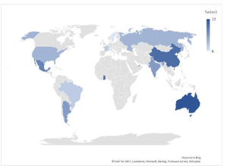

* Updating our Software Requirements Specification document to include game’s UI aspects
  + User Modes: Signed in user, Signed out user, Signed in admin (?)
  + User interfaces requirements
    - Lists all the different UI elements we’d like to have such as drop-down menus for each toolbar element in the dashboard, each screen in the “How to Play” sequence, etc
* Worked on creating a flowchart to help us make our Figma and SRS in a more smooth fashion
  + Shows how users traverse through the menus
  + 3 different sections:
    - Menus for a signed out user / admin
    - Menus for a signed in user
    - Menus for a signed in admin
* Discussed more of how we want to set the game up:
  + 2 types of players: users and admins
    - Users = non-admin players who can only join games
    - Admins = players who are able to create games and spectate games they’ve created
  + 2 different UI’s for users and admins where they have access to different buttons
  + 2 different options for players to create / join teams:
    - 1) Algorithm
      * Players will have option to either create team, or to join the player pool
      * Team leaders (those who create teams) will be able to set their name and slogan
      * Players in player pool will simply have to wait for game host (one who created the session) to start the game
      * Once game has been started, then the algorithm is in charge of creating balanced-size teams to the best of its ability
      * From here, then everybody buys product lines and such
    - 2) Player choice
      * Players will have option to either create team, or to join a team
      * Team leaders (those who create teams) will be able to set their name and slogan, as well as invite players from a list of available players that they can view
        + Invite through email, maybe sending the player the team’s Team ID
      * Players who want to join a team can view a list of open teams and request to join a team
        + Request through email, will be sent team ID that they’d need to join a team
      * Team leaders also have the ability to kick players, and close their team so that they no longer receive requests to join
  + Being able to create admin / user accounts:
    - Schools / Organizations will receive a purchase ID upon buying our product, and can send these ID’s to their teachers / organization leaders
    - When these teachers / organization leaders sign up, they need a valid product ID in order to be able to sign up as an admin
    - Without a product ID, a player will just be a regular user
  + Other details:
    - Maximum players per team: 5
    - Minimum teams: 2
    - Minimum players for teams: 1 - 2 (which one?)

**What we aim to do in the next 2 weeks:**

1. Create a navigable prototype with functioning buttons in the prototype (?)
2. Finish our flowchart
3. Continue work on the SRS document
4. Focus more on the game rules and other aspects of the game that Nana has assigned us per week

# Presentation 1 (Weeks 1 and 2)

**What we’ve done in the past 2 weeks:**

* Learned various game theories that VitalBlinks uses
* Learned how VitalBlinks works as a game
* Formed ideas for game user interface / user experience

**Ideas we’ve created on implementing the game:**

* Most likely a 2D game
* For user interface, use map from physical game board as way for players to navigate levels
  + Gray out / Highlight levels as appropriate

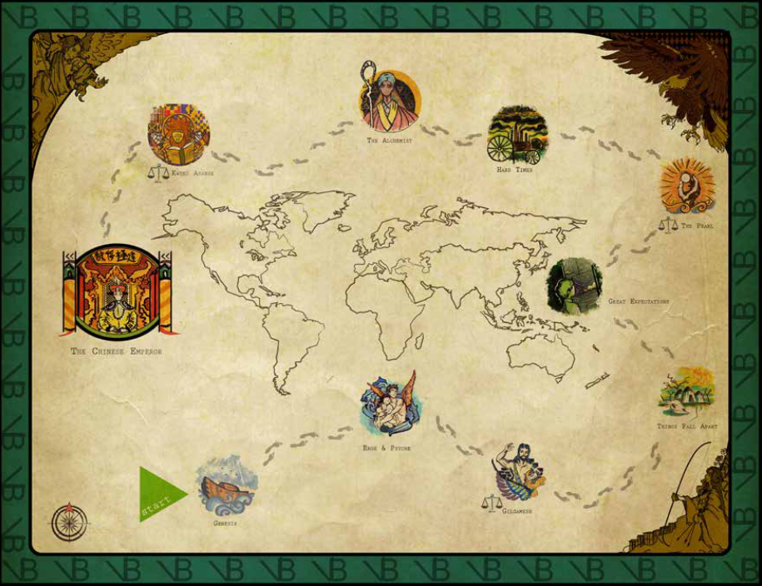

**What we aim to do for the next 2 weeks:**

* Begin work on:  
   1) Software Requirement Specification (SRS) document
  + - Involves the game’s:
      * Basic skeleton / requirements
      * Framework

2) User interface mapping document

* Explore more game theories / greek myths that may be better for certain levels
* Potentially start sketches on game design

Begin work on Software Requirement Specification (SRS) document and design the UI framework and work on the user navigation of each level.We plan to make a software with clickable buttons where you can navigate to different levels. We also plan to create User interface mapping document